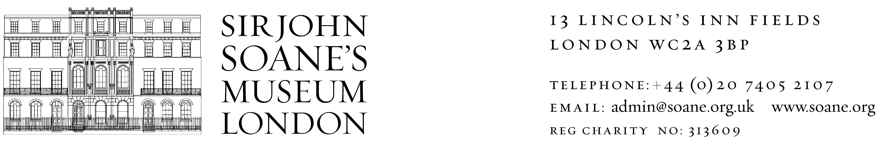
Volunteer Visitor Assistant

Volunteering alongside experienced members of staff, and playing an integral role in the daily running of the Museum, Volunteer Visitor Assistants help to provide our visitors with a world-class visitor experience.
The role includes welcoming visitors to the Museum, interpreting the different and unique spaces for visitors, and safeguarding the collections to ensure they remain as they were left in 1837 for future generations of visitors. On a rotational basis Volunteer Visitor Assistants are situated in key areas of the museum including; the Crypt with the famous sarcophagus of Seti I, the unique Colonnade where Soane displayed his collection of classical relics and plaster casts, and the old Kitchens.

Why volunteer at Sir John Soane’s Museum?

- Meet new people - from visitors, to members of staff, to fellow volunteers - with a variety of interests and expertise
- Engage with local history and architecture
- Learn new skills and gain work related experience
- Be invited to take part in talks and events at the Museum.
- Training and support from a volunteer supervisor
- Reimbursement for out-of-pocket travel expenses will be paid, up to a maximum of £12.50 a day

Who can be a Volunteer Visitor Assistant?

We welcome applicants from all sections of the community. As an organisation we want to offer opportunities especially to those from our local community and to people new to museums and heritage.
Through this role volunteers will develop skills in customer service and knowledge about museums and the collections.
We are looking for volunteers who can demonstrate the following qualities:

- Friendly and welcoming
- Happy to communicate with visitors
- Good time keeping skills.
- Happy working independently and in a team
- Interested in learning more about the Museum
- Willing to attend an induction and training sessions.

Above all, we are looking for volunteers who are enthusiastic about the role and able to work with our close-knit team of staff and volunteers.

Time commitment

The role of a Volunteer Visitor Assistant best suits someone who is able to offer their time for at least three months, consisting of a regular duty on either a morning (10am-1:30pm) or an afternoon (1:30pm-5pm) once a week or once a fortnight; an all day shift (10am-5pm) is also an option. We can discuss more flexible volunteering if needed, please get in touch with the Volunteer Manager if you would like to discuss this.

Shifts take place during Museum opening hours, 10am-5pm from Wednesday – Sunday.

How to apply

If you are interested, please complete a Volunteer Registration form and send it to: Katie Weston, Volunteer Manager, 13 Lincoln’s Inn Fields, London, WC2A 3BP or by email to Volunteer@soane.org.uk

