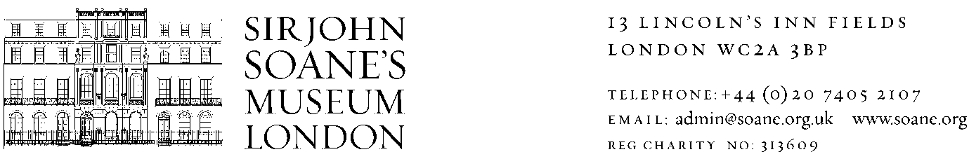

**FINANCE ASSISTANT**

**REPORTS TO: FINANCE MANAGER**

**JOB DESCRIPTION and PERSON SPECIFICATION**

**Background information**

The house-museum of the celebrated Regency architect, Sir John Soane, displays his varied and idiosyncratic collections just as he left them on his death in 1837. This National Museum receives more than 120,000 visitors a year and employs around 70 staff, with full programmes of education, exhibitions, research and publication.

The Museum receives some government funding from the Department for Digital, Culture, Media and Sport (DCMS ) but also needs to be focussed on securing other income sources and controlling its cost base to ensure financial resilience and sustainability in the future. The Finance Team is a key support service in the achievement of this process delivering timely, accurate and informative reports.

The Museum is a Registered Charity, governed by unincorporated Trustees and constituted by the Sir John Soane’s Museum Order. The Museum is VAT registered and reclaims VAT under Section 33(a) as a National Museum. The Museum is a Non-Departmental Public Body (NDPB) sponsored by DCMS and as and seeks to be an inclusive employer.

**Job Profile**

To assist the Finance Manager in the day-to-day financial affairs of the Museum, its trading subsidiary Soane Museum Enterprises Ltd and an independent charity Sir John Soane’s Museum Trust.

This post requires attention to detail, the ability to take an overview and to make progress with several tasks in parallel. It is also an opportunity to work in a small and friendly, but high profile National Museum at a busy and exciting time.

**Main duties and responsibilities**

* Receive supplier invoices and credit notes, check and confirm liability for payment, ensure correct codes and authorisation
* Process supplier invoices and credit notes promptly and accurately, and input onto our accounts system (Sage Line 50) on a daily basis
* Code and process staff expense forms
* Set up new supplier accounts, completing any necessary paperwork
* Prepare and process purchase ledger payments using mainly BACS. Liaise with suppliers and staff to resolve queries, disputes and deal with general finance queries
* Bank sales receipts, match against invoices on a daily basis
* Manage and reconcile petty cash
* Manage donation boxes on a weekly basis
* Process Credit Card statements plus perform reconciliations monthly.
* Prepare gift aid claims quarterly
* Provide information to external and internal auditors
* Build good working relationships with key internal and external customers
* General administrative work e.g. filing, archiving

**Person Specification and Skills**

**(E=Essential Criteria, D = Desirable Criteria)**

* Part or fully qualified AAT/Accountancy qualification or two years relevant, practical accounts experience (E)
* Knowledge and experience of charity accounting requirements (D)
* Working knowledge of computerised accounting systems (E) preferably Sage line 50 (D)
* IT skills especially in Excel (E)
* Sound verbal and written communication skills (E)
* Ability to deal tactfully and sympathetically with all internal and external stakeholders (E)
* Understanding of and commitment to equality, diversity and inclusion principles in practice (E)
* Ability to work professionally, to prioritise competing tasks, to work effectively and accurately under pressure to meet tight deadlines (E)
* Commitment to own learning and professional development (E)

**Remuneration**

This is a full-time and permanent post of 35 hours per week at a salary of £21,000 per annum.

**Benefits**

26.5 days annual leave plus bank holidays

Membership of the Principal Civil Service Pension Scheme (Alpha)

Interest free season ticket loan for travel to and from work

**Applications**

Please apply by sending a covering letter and CV to [**recruitment@soane.org.uk**](mailto:recruitment@soane.org.uk)

The deadline for applications is 5.00pm Friday 19 October 2018.

Interviews will be held on Friday 26th October 2018 at the Museum which is located at 13 Lincoln’s Inn Fields, London WC2A 3BP.

A Basic Disclosure and Barring check is required for this post.

Our 2017/18 Annual Report and Accounts can be found on our website, [www.soane.org](http://www.soane.org)

Sir John Soane’s Museum is a Non-Departmental Public Body (NDPB) whose prime sponsor is the Department for Culture, Media and Sport (DCMS)

Registered Charity no. 313609