- A partridge in a pear tree,
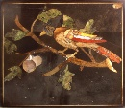
Plaque (from a cabinet?) in pietre dure, depicting a bird perched on the branch of a fruit tree
17th Century
Firenze (Florence)
Museum number: S60

2. Two turtle doves,
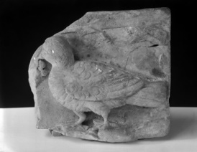
Fragment of a Roman relief depicting a dove, foliage and part of a landscape
Grey Greek marble
Height: 20cm
Width: 21cm
Thickness: 7cm
Museum number: X30

3. Three french hens,
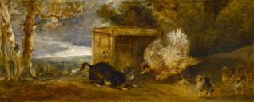
Sir Peter Francis Bourgeois (1756 - 1811)
A hen defending her chickens
Undated
Oil on canvas
Height: 37cm, sight size
Width: 98cm, sight size
Museum number: P60

4. Four calling birds,
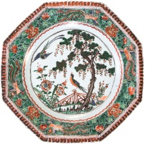
An octagonal Chinese "famille verte" dish painted with a landscape with a bridge, flowers and birds
Kangxi period (17th Century)
China
Glazed porcelain
Diameter: 15.5in
Museum number: B46

5. Five gold rings,
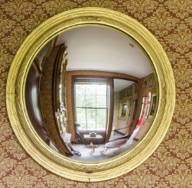
Circular mirror in gilt frame, English, unknown maker, early nineteenth century and 2015
Hand silvered mirror glass and gilt wood
Diameter: 73.5cm
Width (frame): 7.5cm
Museum number: XF31

6. Six geese a-laying
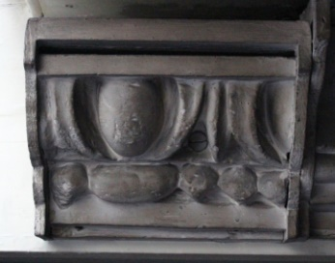
Cast of a fragment of egg and dart moulding
Plaster cast, in a shaped timber frame
Museum number: M1360

7. Seven swans a-swimming,
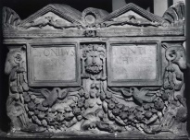
A Roman double funerary urn (cinerarium) wtih separate lid
Pentelic marble
Height: 35cm
Height (excluding lid): 26cm
Width (lid): 47.5cm
Length (lid): 34.5cm
Museum number: M421

8. Eight maids a-milking,
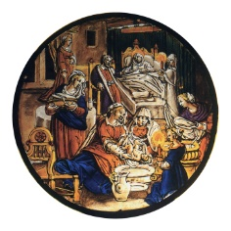Birth of the Virgin, stained glass roundel, Netherlandish or German, 17th century
Clear glass with brown and black paints, yellow stain, red-brown and deep blue enamels and purple, probably a combination of blue over red enamels
Diameter: 138mm, approximate
Museum number: SG1

9. Nine ladies dancing,
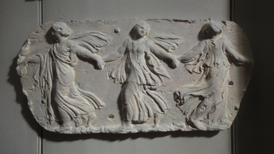
Cast of an antique relief showing three women dancing (?see also M818, MP235)
Plaster cast
Museum number: M154

10. Ten lords a-leaping,
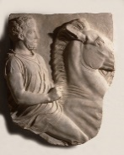
Cast of fragment of one of Lord Elgin’s marbles (not from the Acropolis), rider on horse
Plaster cast
Height: 710mm
Width: 580mm, at the widest part
Depth: 145mm
Museum number: A80

11. Eleven pipers piping,

Cast of a console from the Villa Poniatowsky, Rome
Plaster cast
Museum number: M950

12. Twelve drummers drumming
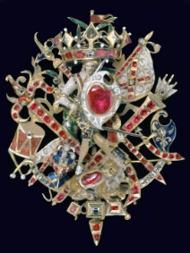
The 'Naseby Jewel', a cap badge, German, early 17th century
Gold and enamel, set with rubies and diamonds
Height: 90 mm
Width: 65mm
Museum number: SDR21.33

